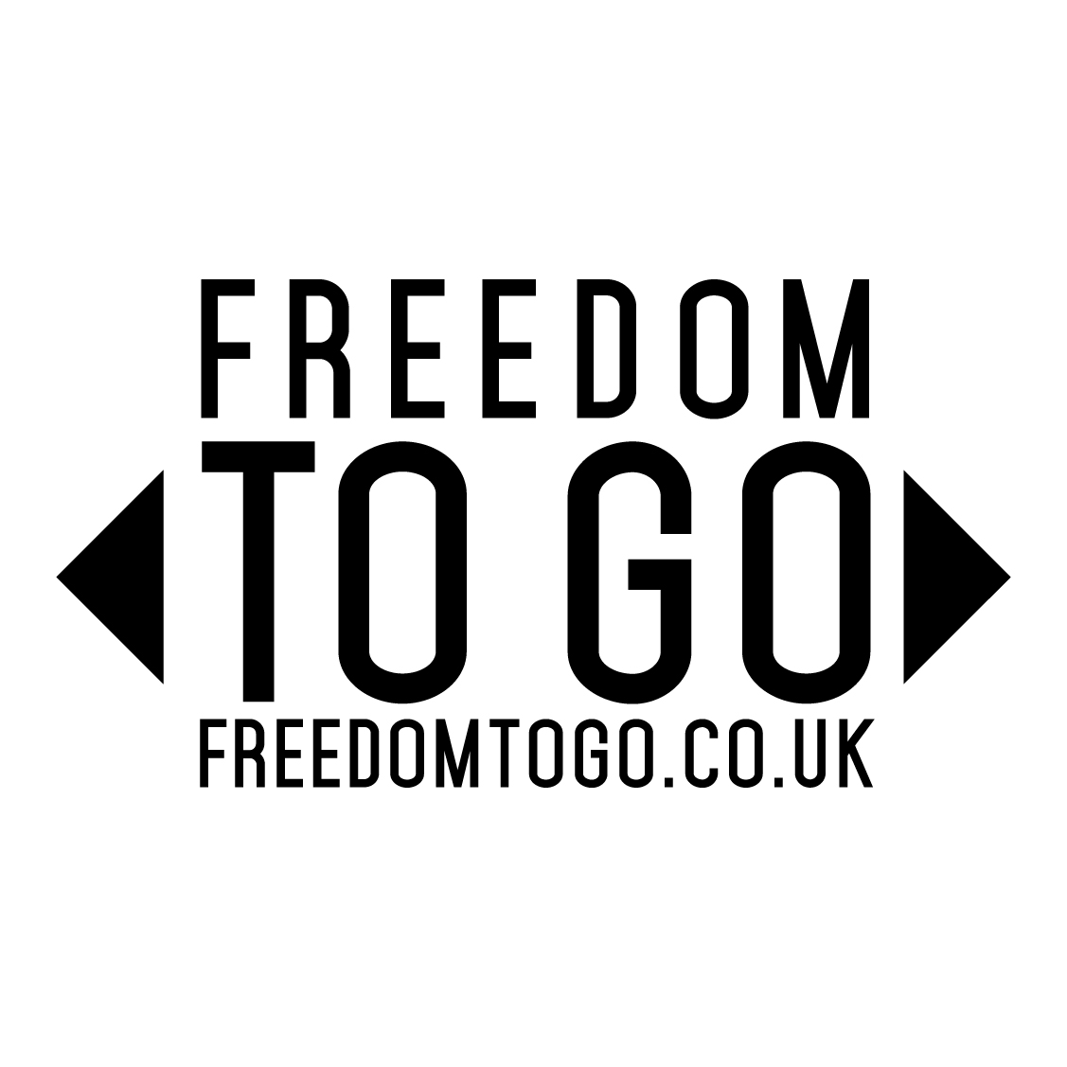
Surf’s Up!
With spring most definitely in the air, rising surfing star Melodie King will soon be kicking off her 2015 competitive season in style as an ambassador for Freedom to Go - a campaign promoting the lifestyle benefits of short breaks in leisure vehicles and encouraging people to take more of them.
Throughout the year Melodie will be blogging exclusively at freedomtogo.co.uk about her sporting adventures facilitated by an Elddis Autoquest 180 motorhome, showing how simple it is to hit the road in one.
Melodie kicks off her competitive action on April 25th at the 2015 Aquajuice British Schools Surf Championships in Cornwall and she will be using an Elddis Autoquest 180 motorhome for her entire 2015 surfing season. She is already backed by some of the biggest surfing brands, including Bos Surfboards and Hurricane.
Rachel Piggot from Freedom to Go said: “We’re absolutely delighted to be working with Melodie as she is a fantastic competitor on an upward trajectory and lover of the great outdoors. She understands perfectly how a leisure vehicle can help facilitate her career, having been around campervans and motorhomes for years, and we’re excited to see how well she does this year. Freedomtogo.co.uk will be telling her surfing story throughout the summer and beyond!”
Having been around the surfing scene since a young age, Melodie only got into surfing herself three years ago and now it’s her life. She made a big impact on surf competitions in 2014 and is now ranked 5th in the UK Pro Tour (UKPSA) under 18’s category for surfing and 10th in the women’s division. This year she will be looking to improve on this ranking by competing in events across the UK from Scotland to Cornwall. Check out these videos of Melodie here.
Melodie King said: “After a long winter training I can’t wait to get back in competitive action and having an Elddis motorhome to help me compete is amazing. We have to travel to loads of different locations and often finding accommodation can be tricky, especially when you have five surfboards, wetsuits and other kit to think about. Having a motorhome makes things much easier. I’m also stoked to be working with Freedom to Go as I share the ethos behind the campaign to get more people active and into the great outdoors.”
Rachel Moncrieff, Elddis Marketing & Communications Manager, is delighted that the company is able to support Melodie in her quest by loaning one of its best-selling family friendly motorhomes. She said: “Melodie personifies the lifestyle that motorhomes enable and we believe the Elddis Autoquest 180 will allow her to get closer to the action and enjoy an even richer experience. We’re all fully behind her and wish her every success for the coming season!”
The NCC (National Caravan Council) has partnered with The Caravan Club and The Camping and Caravanning Club, on Freedom to Go, an awareness building campaign to promote the lifestyle benefits of caravan and motorhome holidays. At the heart of the campaign freedomtogo.co.uk offers guidance and advice to help visitors discover and plan a new adventure. The campaign will also show how a motorhome or caravan can enable many activities, such as surfing, and draw on the appeal of the great outdoors and the freedom to explore that owning a leisure vehicle presents.
Follow Melodie on Instagram and on Twitter
Follow Elddis on Twitter and like it on Facebook
Follow Freedom to Go on Twitter and like it on Facebook
ENDS

Notes to editors
Download a selection of high resolution images here;
https://www.dropbox.com/sh/s28l5l50a4banse/AADa1JIZzagLV8HDV8x2v7Uka?dl=0
The term ‘Leisure vehicle’ encompasses trailer tents, touring caravans, motor homes, campervans caravan holiday homes, lodges and camping pods.
The NCC is the trade association for the UK caravan industry, encompassing touring caravans, motorhomes, caravan holiday homes and park homes. The NCC represents some 800 member outlets in manufacturing, park operations, distribution, retailing, and in the provisions of specialist suppliers and services within the UK caravan industry, which is worth in excess of £6 billion per annum (sale of products, services and holiday spend).
The Caravan Club is Europe’s premier touring organisation representing over one million caravanners, motor caravanners and trailer tenters. The Caravan Club has been providing people with the means to enjoy touring holidays since 1907 and offers a wealth of products, information and services, bespoke for caravanners.
The Camping and Caravanning Club is 113-years-old and is the largest and oldest Club in the world for all forms of camping. It has 109 award-winning sites throughout the UK and, through a partnership with the Forestry Commission, now runs and manages a further 16 Camping in the Forest touring sites.
Press contact: Paul Mauerhoff – paul.m@thencc.org.uk – 01252 796 092

